PHARMACY Q-COMMERCE
1. The whole system
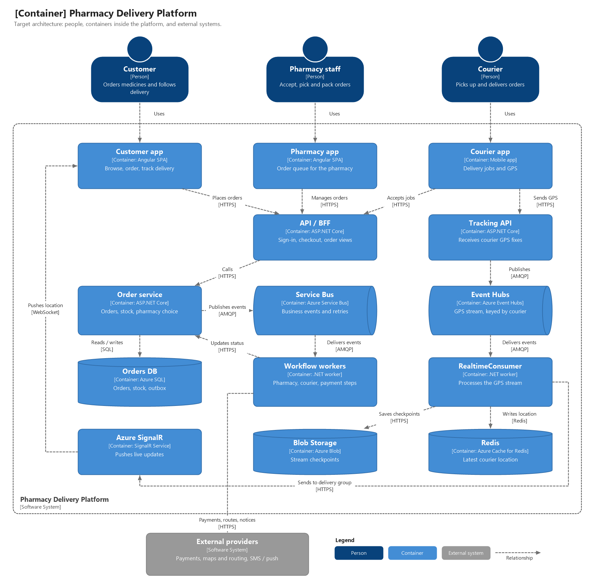
The system has two paths that do not depend on each other:
• Order path (left and centre). Rare but important changes: orders, stock and payments. Correctness matters the most.
• Tracking path (right). Many small location updates every second. Speed and volume matter the most.
• Both paths share the customer app and Azure SignalR only at the edge, so load on one path does not slow the other.
2. Goals
• Never lose or duplicate an order, an inventory reservation or a payment.
• Keep checkout fast for best user experience. Slow processing runs later in the background.
• Show the courier's position to the customer within a few seconds.
• Let each part grow independently.
3. Placing and fulfilling an order
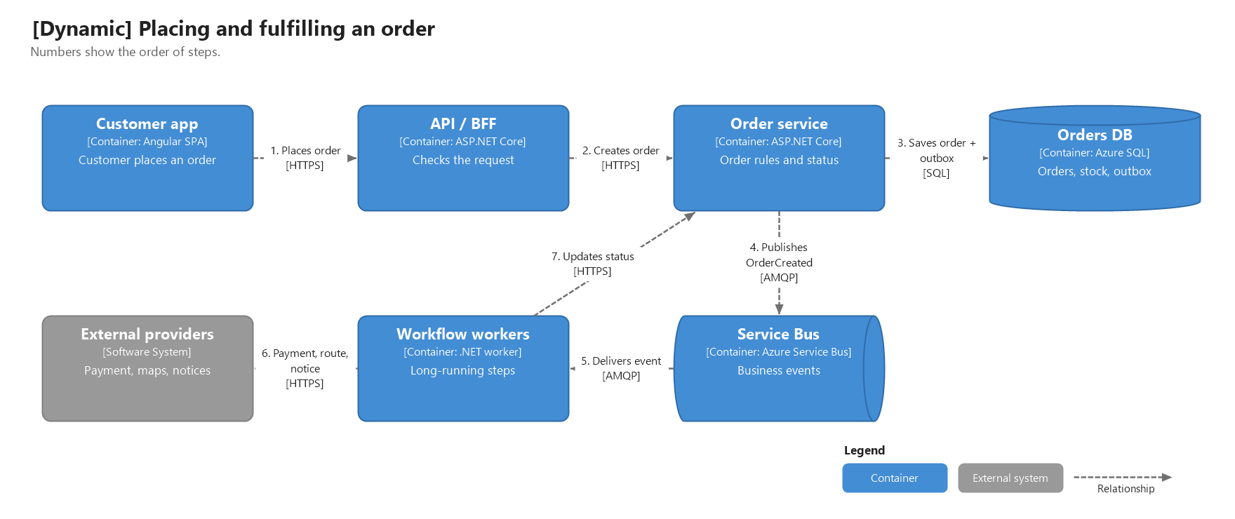
1. The customer places an order in the app.
2. The BFF checks the request and asks the Order service to create the order.
3. The Order service checks prescription, price and stock, then saves the order, the inventory reservation and an OrderCreated event in one SQL transaction. The customer gets an order number right away.
4. A background task in the Order service reads new events from the outbox table and publishes them to Service Bus.
5. Service Bus delivers the event to the workflow workers.
6. Workers choose a pharmacy, book a courier, take payment and send notices, calling external providers when needed.
7. Workers report progress back to the Order service, which moves the order to its next status.

Order statuses: Created => Reserved => PharmacyAssigned => Accepted => Picking => ReadyForPickup => CourierAssigned => PickedUp => Delivered. Cancellation and different failures (inventory/payment) are explicit statuses too.
4. Live delivery tracking
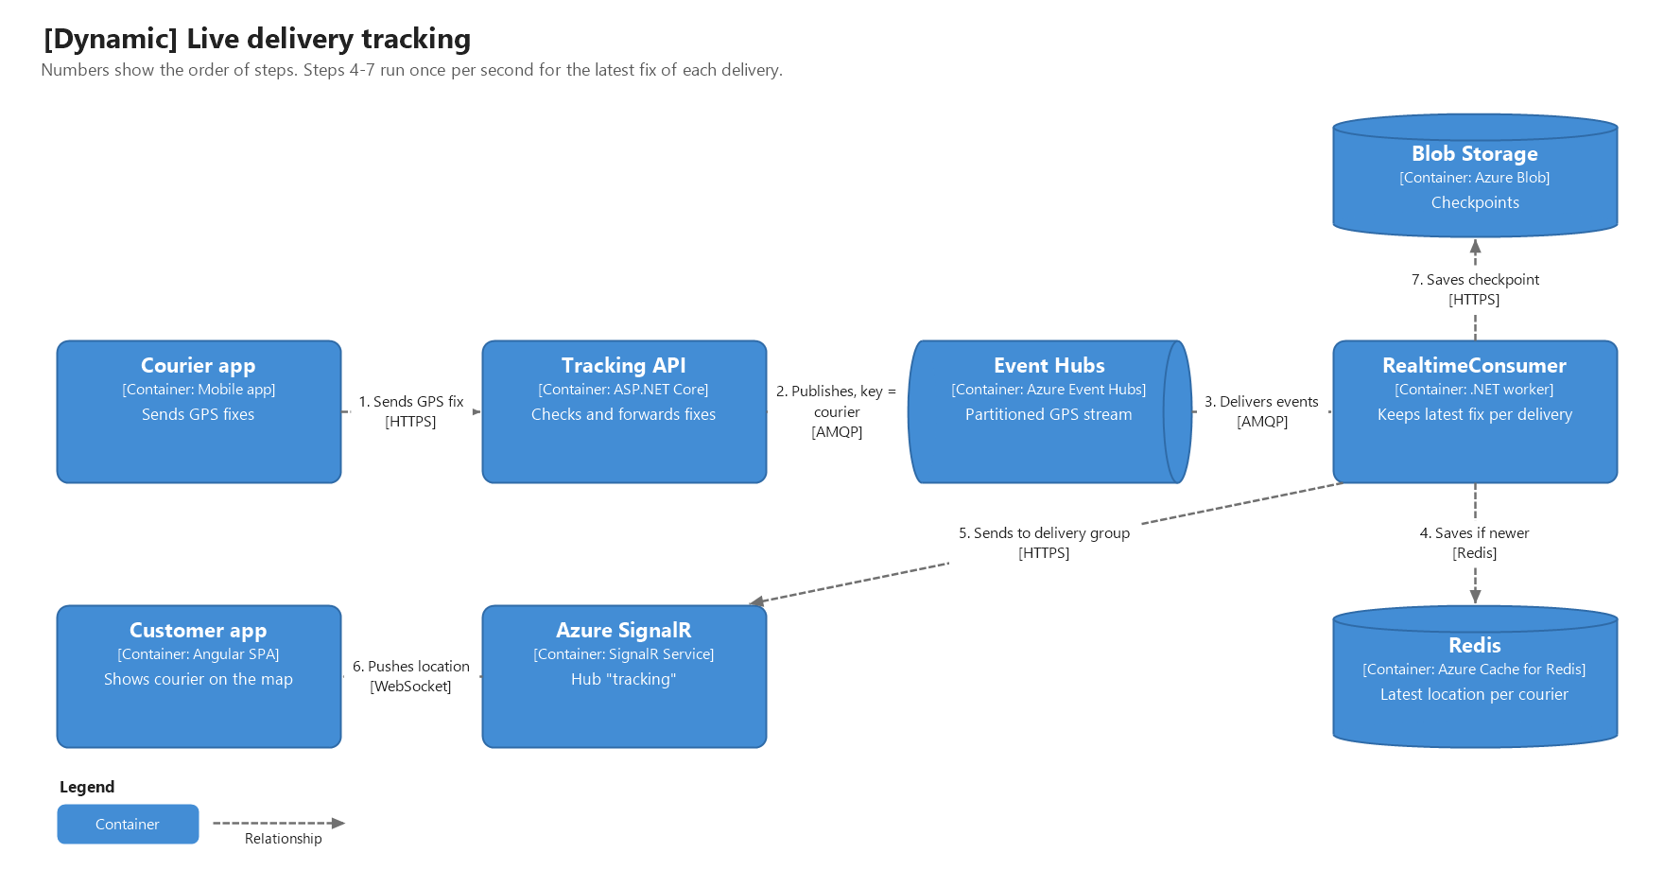
1. The courier app sends a location update to the Tracking API.
2. The Tracking API checks it and publishes it to Event Hubs, using the courier Id as the partition key. All updates from one courier stay in order.
3. Event Hubs delivers the updates to RealtimeConsumer.
4. Once per second, the consumer saves the newest update of each delivery to Redis. Older updates are ignored.
5. It sends the same update to SignalR for that delivery.
6. SignalR pushes the update to the customers watching that delivery.
7. Consumer saves the checkpoint only after steps 4 and 5 succeed, so nothing is lost on restarts.

5. How each part scales
Container | How to scale
API / BFF, Tracking API | Add more copies when requests or CPU grow.
Order service | Add more copies; scale Azure SQL up when needed.
Workflow workers | Add copies when messages wait too long in Service Bus.
RealtimeConsumer | Add copies when Event Hubs lag grows.
Event Hubs | Add throughput units.
Redis, SignalR, Blob | Move to a larger tier.

6. Key decisions
Decision | Reason
Two separate paths: orders and tracking | They have very different load. Keeping them apart lets each be simple and scale independently.
Outbox table in SQL | The order and its event are saved together. If Service Bus is down, the event is sent later instead of being lost.
Service Bus for orders, Event Hubs for GPS | Service Bus is best for important messages that need retries. Event Hubs is best for large streams of small updates.
Redis for location, SQL for orders | Location changes every second and are constantly overwritten. Orders change seldom and have complex structure.
Keep only the latest location update | Customers need the current position, not every point. Sending fewer updates reduces Redis and SignalR load.
SignalR groups per delivery | Each customer gets only their own updates, without polling.

7. Reliability and security
• Message can arrive twice. Every handler checks the idempotency key (id, timestamp or a hash) and ignores repeats.
• Temporary errors are retried a few times with a delay (or with a circuit breaker) using Polly. Messages that keep failing go to a dead-letter queue and raise a support alert.
• Apps sign in with an identity provider. The BFF checks whether a user is authorized to see an order before showing it or joining order’s SignalR group.
• Prescription data is encrypted, access is logged.
• Services use managed identities instead of passwords. Secrets are kept in Key Vault.
• Each request and event carries order, delivery and courier IDs so problems can be traced end to end.

